1. **Defect ID:** DEF-003
2. **Title:** Order is placed without anything in the cart.
3. **Description:** When user order
4. **Environment:** SIT
5. **Severity:** 1 - High
6. **Priority:** P1 – High
7. **Status:** New
8. **Steps to Reproduce:**

* Open the e-commerce site(*https://www.saucedemo.com/v1/index.html*) on a Chrome Browser.
* Navigate to the Landing page.
* Add item to the cart.
* Navigate to the checkout page.
* Fill in Your First Name and Last Name as Numeric value
* Fill in your Postal address as only alphabates.
* Tap the “Continue” button.
* Click on Finish Button
* Message received as “Thank You For Your Order”

1. **Expected Result:** Order is placed with Numeric name and alphabetic Postal address.
2. **Actual Result:** order shouldn’t be placed with Numeric name and alphabetic Postal address. As Name should be Alphabetic and Postal address should be Alphanumeric.
3. **Attachments:**

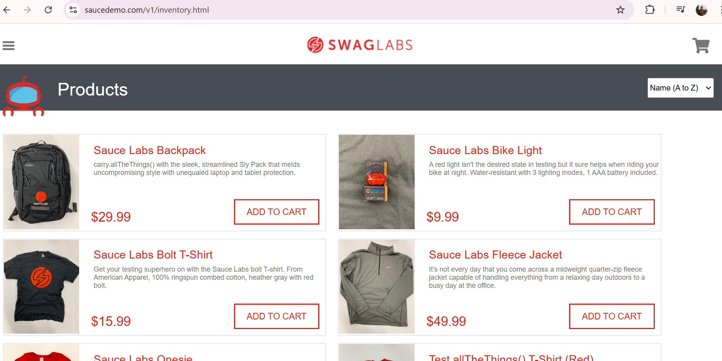

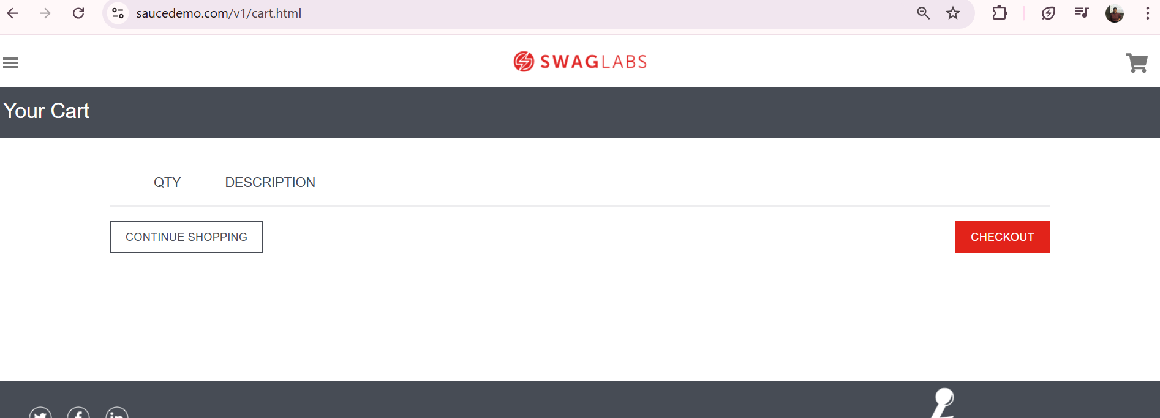

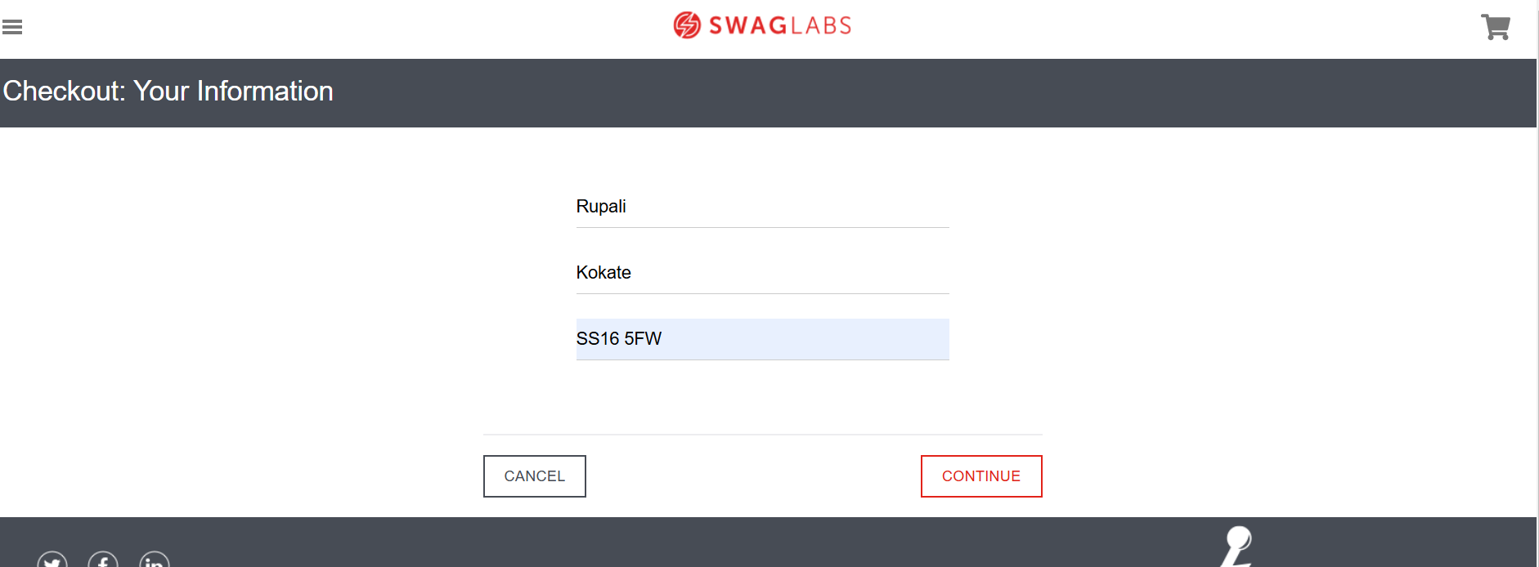

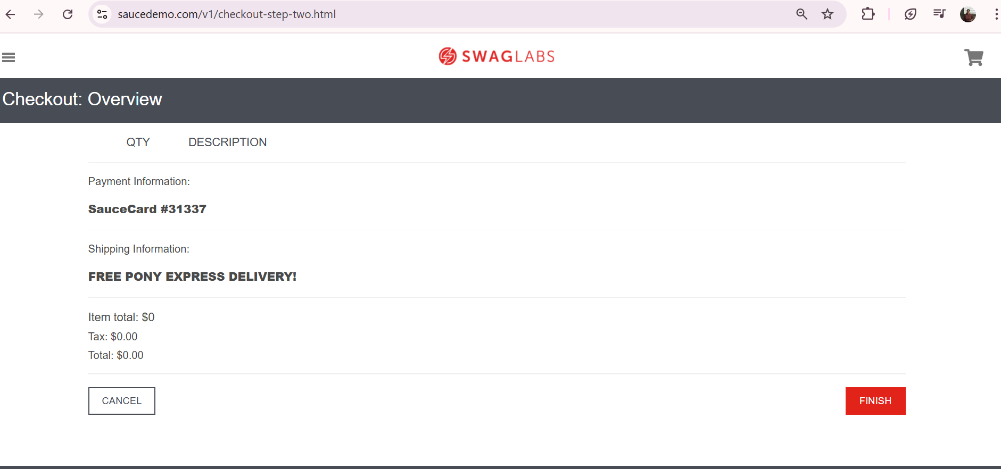

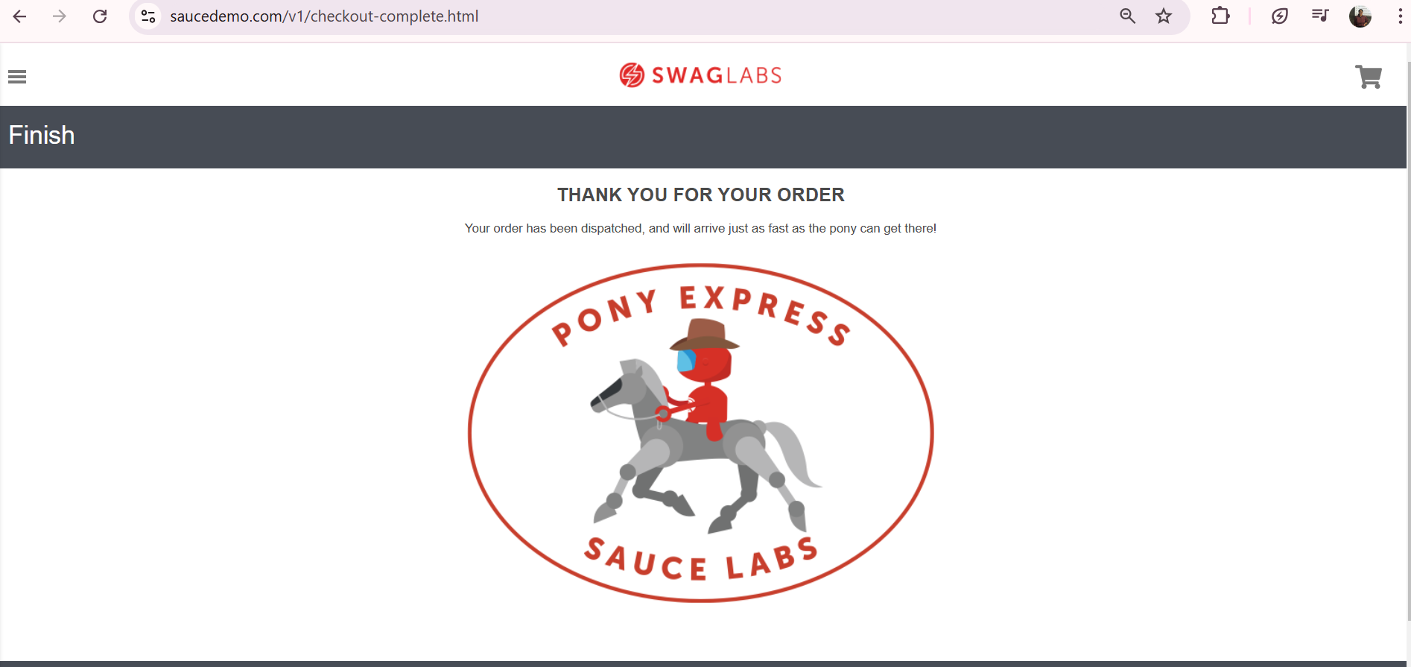

**12. Reported By:** Rupali Kokate

**13. Date Reported:** 01/11/2024

**14. Assigned To:** Katie Jones